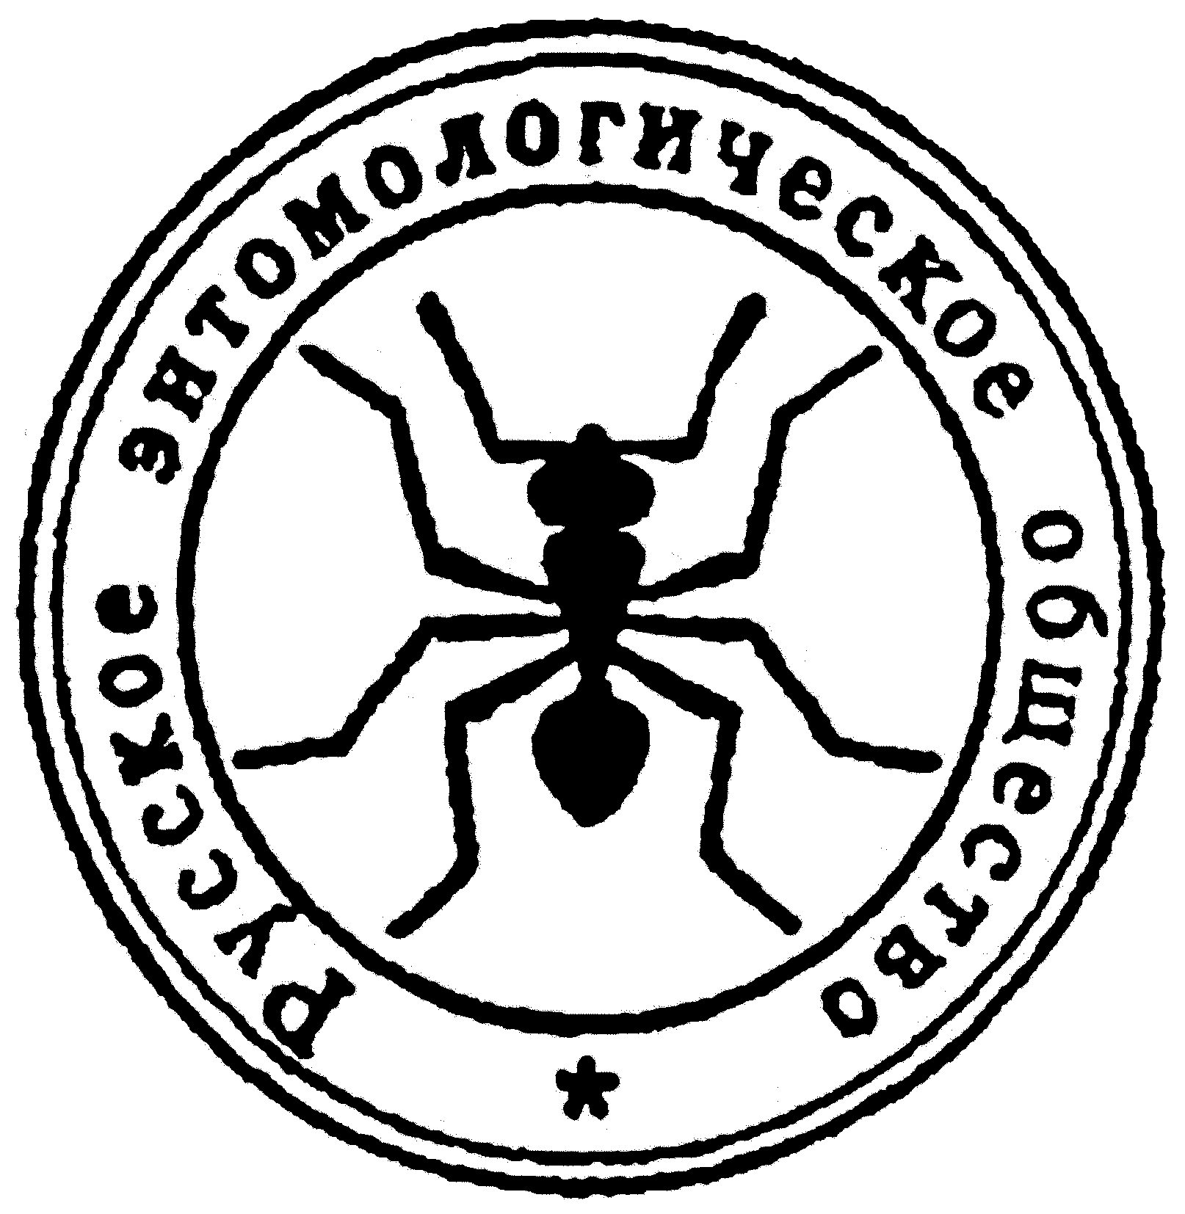  150 years  of the  Russian  Entomological  Society  St. Petersburg  2009  Programme  (duration of lectures 20-25 min.)  2 April, 10.00  Medvedev G.S. (President of RES, Zoological Institute RAS). Past, present and future of the Russian Entomological Society.  Rasnitsyn A.P. (Palaeontological Institute RAS). The problems of molecular and morphological cladistics: view of paleontologist.  Balashov Yu. S. (Zoological Institute RAS). Academician E.N. Pavlovsky as entomologist and the President of All-Union Entomological Society.  Coffee break (15 min.)  Selikhovkin A.V., Bondarenko E.A., Popovichev B.G. (St. Petersburg лесотехническая Academy). Modern forest entomology: directions of investigation, problems and perspectives.  Lelej A.S., Storozhenko S.Yu. (Institute of Biology and Soil Sciences, Far-Eastern Branch of RAS). Biodiversity of insects in the Russian Far East.  Kuznetsova V.G., Lukhtanov V.A. (Zoological Institute RAS; St. Petersburg State University). What genes and chromosomes can say about origin and evolution of the Insecta orders?  Lunch |  | Dear Colleagues!  You are kindly invited to participate  in the scientific conference dedicated to  150 anniversary of the  Russian Entomological Society  «Theoretical and applied entomology: past, present, and future»  The Conference will be held at  April 2, 2009  in the Conference Hall of Zoological Institute, Russian Academy of Sciences  Address: St. Petersburg, Universitetskaya emb., 1  2 April, 14.30  Pavlyushin V.A. (All-Russian Institute of Plant Protection). Agro-ecosystem approach to solution of the problems of agricultural entomology.  Rusina L.Yu. (Kherson State University, Ukraine). Population regulation in social wasps: search of the nature of mechanisms.  Sergeev M.S. (Institute of animal systematics and ecology, Siberian Branch of RAS; Novosibirsk State University). Spaces of the classic and modern biogeography: the ways of the Russian entomologists.  Coffee break (15 min.)  Knyazev A.N. (I.M. Sechenov Institute of evolutionary physiology and biochemistry). The place of experimental entomology in the resolving of the fundamental problems of physiology and medicine.  Zamotajlov A.S., Miroshnikov A.I., Nabozhenko M.V., Nejmorovets V.V., Orlov V.N., Shapovalov M.I., Shokhin I.V., Shchurov V.I. (State Agricultural University, Krasnodar). Main paths of the formation of entomocomplexes of the North-Western Caucasus.  Kipjatkov V.E., Lopatina E.B. (St. Petersburg State University). Intraspecific variability of the temperature norms of insect development: reality, nature, and adaptive significance.

