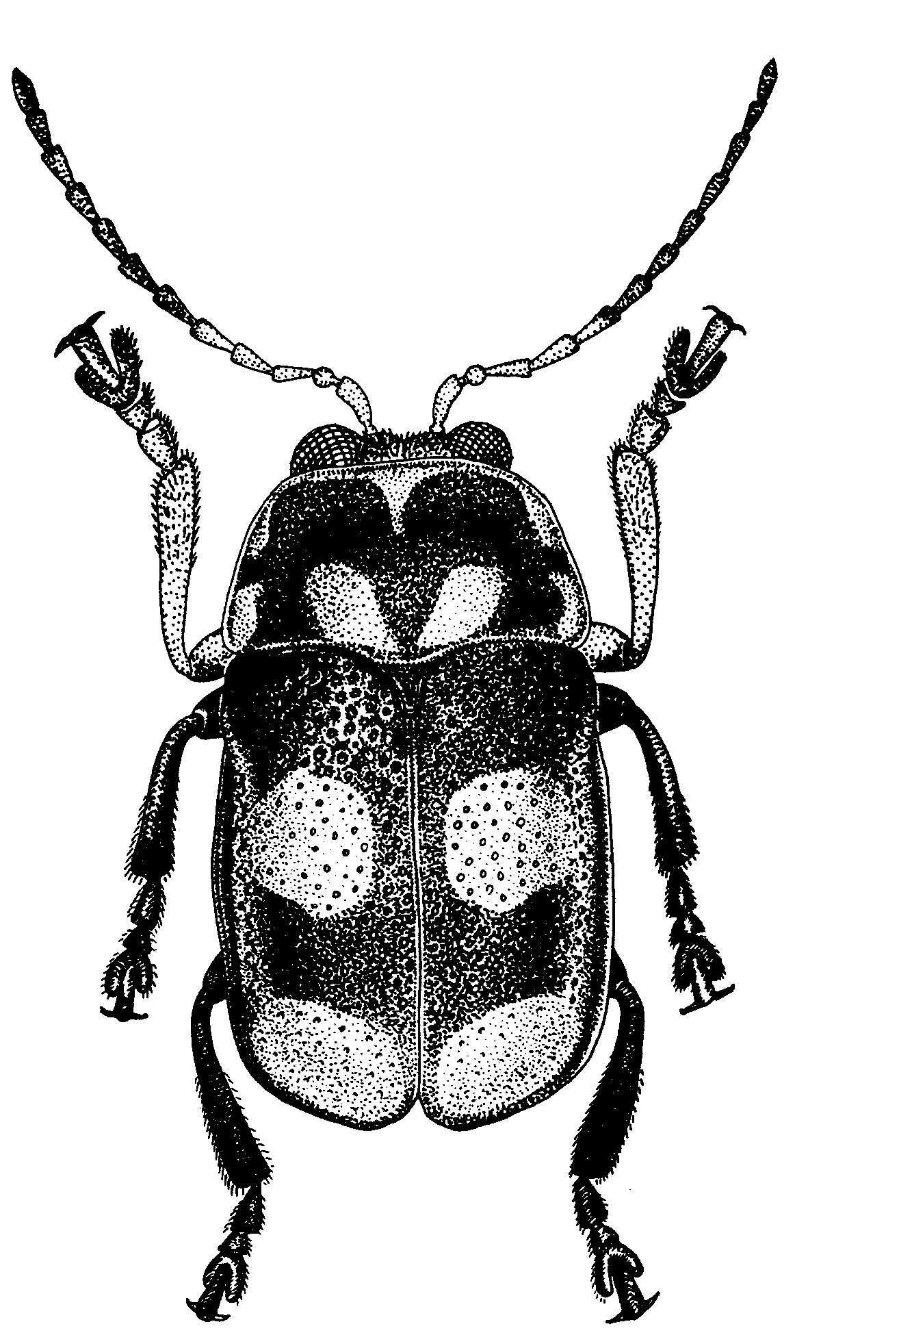
Рис. 666 - Cryptocephalus tetratyrus Sols.

