
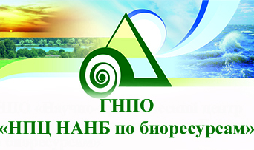
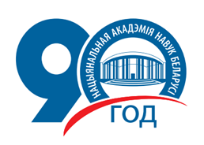

The National Academy of Sciences of Belarus
The State Scientific and Production Amalgamation «Scientific and Practical Center of the National Academy of Sciences of Belarus for Biological Resources»

«Current challenges in Belarus and adjacent regions
wildlife protection»

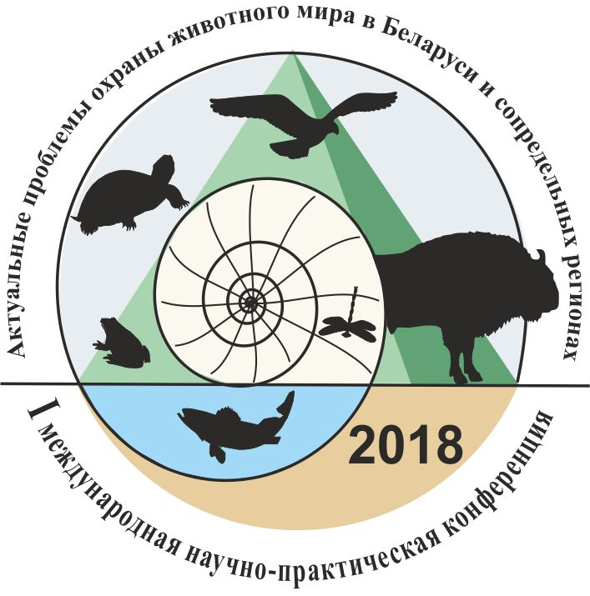

I International scientific and practical conference
from 15th to 18th October 2018

First call for papers

DEAR COLLEAGUES!
We are pleased to invite you to take part in the

I International scientific and practical conference
«Current challenges in Belarus and adjacent regions wildlife protection»

that will be held
from 15th to 18th October 2018

The State Scientific and Production Amalgamation «Scientific and Practical Center of the National Academy of Sciences of Belarus for Biological Resources», Minsk, Republic of Belarus

Conference languages: English, belarusian, russian.

Thematic priorities of the conference:
- Red Data Book: results and directions for the further research.
- Specially protected natural sites as wildlife biodiversity reservations.
- Wildlife monitoring: trends and the major problems.
- Current climatic and anthropogenic factors affecting wildlife.
- The influence of alien species on native fauna.
- Problems and perspectives of the wildlife resources utilization.
- Environmental education and enlightenment as a guarantee of animal welfare.

Forms of participation:
• Speech at the general session (up to 20 minutes)
• Presentation of the report on the section (up to 10 minutes)
• Corresponding participation

For participation you should:
• provide conference materials and brief information about yourself (in accordance with the attached form) in one file and send it to Redbook@biobel.by.
Registration and conference materials submission 1th August – 10th September 2018

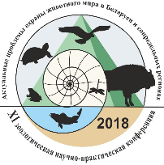
I International scientific and practical conference
«Current challenges in Belarus and adjacent regions
wildlife protection»

Full Name
Country
Organization
Position, academic degree, title
Postal address
Tel.
E-mail
Article title
Language of the report
Form of participation (sectional or general session report, poster, corresponding participation)
Date

Authors are responsible for the materials submitted for the conference. The organizing and scientific Committee has the right to reject articles in case of non-compliance with the scientific level of the conference, violation of the requirements of registration and deadlines for submission of materials.
Information on the article design is given below.

Registration fee:
10 USD (at the National Bank rate at the time of payment) - full-time participation.
5 USD (at the National Bank rate at the time of payment) – for students and corresponding participants.
Registration fee receipts in scanned form should be submitted Redbook@biobel.by before 10th October 2018.
The registration fee should be paid after the confirmation of the conference materials receipt.
Foreign citizens can pay the registration fee upon arrival at the conference. The collection of articles will be published by the beginning of the conference. Each publication in the collection of conference materials will be charged separately. The costs of travel, accommodation and meals are paid by the participants of the conference or their sending organizations.

Organizing committee:
SSPA «SPC NAS of Belarus for Bioresources»
220072, Republic of Belarus, Minsk, Akademicheskaya st. 27

More information:
Laboratory of terrestrial Invertebrates SSPA «SPC NAS of Belarus for Bioresources»
Tel.: +37517 2842354 Setrakova Ekaterina Mihailovna
+37517 2842192, +375 29 1751750 Kulak Anatolij Viktorovich
Deputy General Director for commercial Affairs
Tel.: +37517 2841335 Yasyuchenya Tat'yana Petrovna

E-mail: Redbook@biobel.by

BANKING DETAILS:

For payment in EUR
Recipient: SSPA «SPC NAS of Belarus for Bioresources»,
TRN 100217257, OKPO 03535032
in OAO Belarusbank
Minsk, branch No. 529
BIC AKBBBY21529
r / s BY50 AKBB 3632 9184 7002 8550 0000
Details of payment: «Wildlife protection -2018» registration fee

For payment in USD:
Recipient: SSPA «SPC NAS of Belarus for Bioresources»,
TRN 100217257, OKPO 03535032
in OAO Belarusbank
Minsk, branch No. 529
BIC AKBBBY21529
r / s BY50 AKBB 3632 9184 7002 8550 0000
Details of payment: «Wildlife protection -2018» registration fee

For payment in BYN:
Получатель (Recipient): ГНПО «НПЦ НАН Беларуси по биоресурсам»,
УНП 100217257, ОКПО 03535032
в OAO «Беларусбанк»
г. Минск, филиал № 529
БИК AKBBBY21529
р/с BY50 AKBB 3632 9184 7002 8550 0000
Назначение платежа (Details of payment): оргвзнос «Охрана животных–2018»

Organizing committee:
Волкова Татьяна Валерьевна Ph.D. Biology, SSPA «SPC NAS of Belarus for Bioresources» Deputy General Director for scientific work (moderator)

Артюшевский Владислав Михайлович SSPA «SPC NAS of Belarus for Bioresources» Laboratory of terrestrial vertebrates population Ecology and Control junior research worker;
Гайдученко Елена Сергеевна Ph.D. Biology, SSPA «SPC NAS of Belarus for Bioresources» Laboratory of molecular Zoology senior research worker;
Кулак Анатолий Викторович Ph.D. Biology, SSPA «SPC NAS of Belarus for Bioresources» Laboratory of terrestrial Invertebrates leading research worker;
Ларченко Александра Игоревна SSPA «SPC NAS of Belarus for Bioresources» Laboratory of molecular Zoology junior research worker;
Лобановская Полина Юрьевна SSPA "SPC NAS of Belarus for Bioresources» Laboratory of terrestrial vertebrates population Ecology and Control junior research worker;
Лукашанец Дмитрий Александрович Ph.D. Biology, SSPA «SPC NAS of Belarus for Bioresources» Laboratory of Hydrobiology leading research worker;
Маковецкая Екатерина Валерьевна SSPA «SPC NAS of Belarus for Bioresources» Laboratory of terrestrial Invertebrates junior research worker;
Минченко Дарья Павловна SSPA «SPC NAS of Belarus for Bioresources» Laboratory of terrestrial Invertebrates junior research worker;
Семенова Анастасия Александровна SSPA «SPC NAS of Belarus for Bioresources» Laboratory of terrestrial Invertebrates junior research worker;
Сетракова Екатерина Михайловна SSPA «SPC NAS of Belarus for Bioresources» Laboratory of terrestrial Invertebrates junior research worker;
Скуратович Елена Григорьевна SSPA «SPC NAS of Belarus for Bioresources» Laboratory of terrestrial vertebrates population Ecology and Control junior research worker;
Соловей Оксана Эдуардовна SSPA «SPC NAS of Belarus for Bioresources» Laboratory of terrestrial vertebrates population Ecology and Control junior research worker;
Черноморец Анна Вадимовна SSPA «SPC NAS of Belarus for Bioresources» Laboratory of Ornithology junior research worker;
Шелест Марина Геннадьевна SSPA «SPC NAS of Belarus for Bioresources» Laboratory of terrestrial Invertebrates assistant of I category;
Ясюченя Татьяна Петровна SSPA «SPC NAS of Belarus for Bioresources» Deputy General Director for commercial Affairs.
scientific committee:
CHAIRPERSON:
Никифоров Михаил Ефимович Doctor of biological Sciences, Professor, Belarusian NAS Academician, Belarusian NAS biological Sciences Department Academician-Secretary;

Barševskis Arvīds, Doctor of biological Sciences, Academician, Professor, Daugavpils University Rector (Latvia);
Александрович Олег Родославович Doctor of biological Sciences, Professor, Pomeranian Academy in Slupsk Zoology Department Head (Poland);
Арнольбик Василий Михайлович Ph.D. Agriculture, «Belovezhskaya Pushcha» National Park Deputy Director General for science and environmental education;
Байчоров Владимир Мухтарович Doctor of biological Sciences, SSPA «SPC NAS of Belarus for Bioresources» Sector of Animal Monitoring and Cadaster Head;
Бородин Олег Игоревич Ph.D. Biology, associate professor, SSPA «SPC NAS of Belarus for Bioresources» Laboratory of terrestrial Invertebrates leading research worker;
Буга Сергей Владимирович Doctor of biological Sciences, Professor, Belarusian state University Zoology Department Head;
Бычкова Елизавета Игнатьевна Doctor of biological Sciences, Professor, SSPA «SPC NAS of Belarus for Bioresources» Laboratory of Parasitology Head;
Винчевский Александр Евгеньевич the public organization «APB-BirdLife Belarus» Chief;
Гричик Василий Витальевич Doctor of biological Sciences, Belarusian state University Department of general Ecology and biology teaching Methodology Head, the public organization «APB-BirdLife Belarus» Chairman;
Ивкович Валерий Семенович Ph.D. Agriculture, SNPI «Berezinsky biosphere reserve» Deputy Director for research work;
Козулин Александр Васильевич Ph.D. Biology, SSPA «SPC NAS of Belarus for Bioresources» Sector of international Cooperation and Coordination Head;
Люштык Валерий Семенович SNPI «Naroch National Park Deputy General Director for research work;
Нестеренко Маргарита Борисовна SNPI «National Park «Braslav lakes» Deputy General Director;
Прищепчик Олег Васильевич, Ph.D. Biology, SSPA «SPC NAS of Belarus for Bioresources» Laboratory of terrestrial Invertebrates Head;
Ризевский Виктор Казимирович Ph.D. Biology, associate professor, SSPA «SPC NAS of Belarus for Bioresources» Laboratory of Ichthyology Head;
Рындевич Сергей Константинович, Ph.D. Biology, Baranovichi state University Faculty of pedagogy and psychology Department of natural Sciences associate professor;
Самусенко Ирина Эдуардовна Ph.D. Biology, SSPA «SPC NAS of Belarus for Bioresources» Laboratory of Ornithology Head;
Свидинский Николай Иванович Ministry of natural Resources and environmental Protection of the Republic of Belarus, Department of biological and landscape diversity Head, main Department of waste management, biological and landscape diversity Deputy Head;
Семенченко Виталий Павлович Doctor of biological Sciences, Belarusian NAS corresponding member, SSPA «SPC NAS of Belarus for Bioresources» Laboratory of Hydrobiology Head;
Устин Владимир Владимирович Ph.D. Biology, SSPA «SPC NAS of Belarus for Bioresources» Sector of wildlife Conservation Head;
Чайковский Александр Иванович Ph.D. Biology, SSPA «SPC NAS of Belarus for Bioresources» General Director;
Шакун Василий Васильевич Ph.D. Biology, SSPA «SPC NAS of Belarus for Bioresources» Laboratory of terrestrial vertebrates population Ecology and Control Head;
Янчуревич Ольга Викторовна EI «Yanka Kupala State University of Grodno» Deputy Dean for scientific work of the faculty of biology and ecology.
FORMATTING MATERIALS GUIDELINES:

Recommended article size, references and graphic material including - 5 pages MS Word (A4 demy pages) maximum.
Requirements for the article text:
- times New Roman font, 12 PT;
- line spacing-18 PT;
- paragraph indentation-1.25 cm;
- alignment-width;
– top field – 2 cm, bottom 2 cm, left 3 cm, right – 1.5 cm.
Brief annotation (at most 300 characters with spaces) is required.
The borders of tables and figures should not exceed the width of the main text. Tables should also be simple and formatted using standard Word tools.
The presence of the references citations is required.
The cited literature in the references should be given in alphabetical order. Citations should be given in the text in square brackets.
Please, save files in the extension .doc only!
The file name should consist of the surname of the authors (author), separated by a lower underscore.
Materials should be formatted according to the template below.
Example of materials design
UDC 595.787 (476)

BIOLOGYCAL PECULIARITIES OF RHYPARIOIDES METELKANA (LEDERER, 1861) DIVERING ITS TERRITORIAL SEDENTARY

А.V. КULAK
The State Scientific and Production Amalgamation «Scientific and Practical Center of the National Academy of Sciences of Belarus for Biological Resources», Minsk, Republic of Belarus
e-mail: bel_lepid@mail.ru

It was shown that sedentary of Rhyparioides metelkana (Lepidoptera: Erebidae) is conditioned by complex of special biological aspects of this species: short summer period and short interval of diurnal activity, short life period of certain select imago samples, sedentary of females, cautiousness of caterpillars.

KEY WORDS: Lepidoptera, erebidae, RHYPARIOIDES METELKANA, the red data book, behavior of species, SEDENTARY

Rhyparioides metelkana (Lederer, 1861))……………………(body of text)

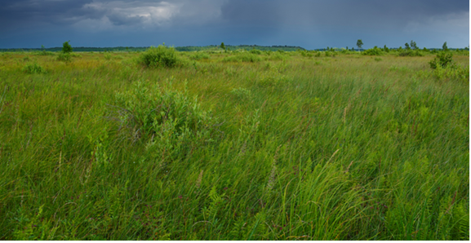
Fig. 1 – Typical «Dzikae» bog site at the National Park «Belovezhskaya Pushcha» 30th June 2016.

Thus, despite the specific requirements for habitat, being a polyphage, Rhyparioides metelkana [1]……………(body of text)

References:
1. Кулак, А.В. Особенности биологии и вопросы охраны медведицы Метельки (Rhyparioides metelkana (Lederer, 1861)) в Европе / А.В. Кулак, Е.А. Держинский // Проблемы рационального использования природных ресурсов и устойчивое развитие Полесья: сб. докл. междунар. науч. конф., Минск, 14-17 сент. 2016 г.: в 2 т. / Нац. акад. наук Беларуси [и др.]; редкол.: В. Г. Гусаков (гл. ред.) [и др.]. – Минск: Беларуская навука, 2016. Т. 2. – С. 410 – 414.
2. Haeger, E. Rhyparioides metelkana Lederer – neu für die DDR (Lep. Arct.) / E. Haeger // Entomologische Nachrichten. – 1973. – № 9. – S. 137-141.
3. Catalogue of the Lepidoptera of Belgium [Electronic resource]. – Mode of access: http://uahost.uantwerpen.be/vve/checklists/lepidoptera/Arctiidae.htm. – Date of access: 05.10.2017.
4. Rákosy, L. Catalogul Lepidopterelor României. Verzeichnis der Schmetterlinge Rumäniens / L. Rákosy, M. Goia, Z. Kovács. – Cluj-Napoca: Soc. Lepid. Rom., 2003. – 447 p.

