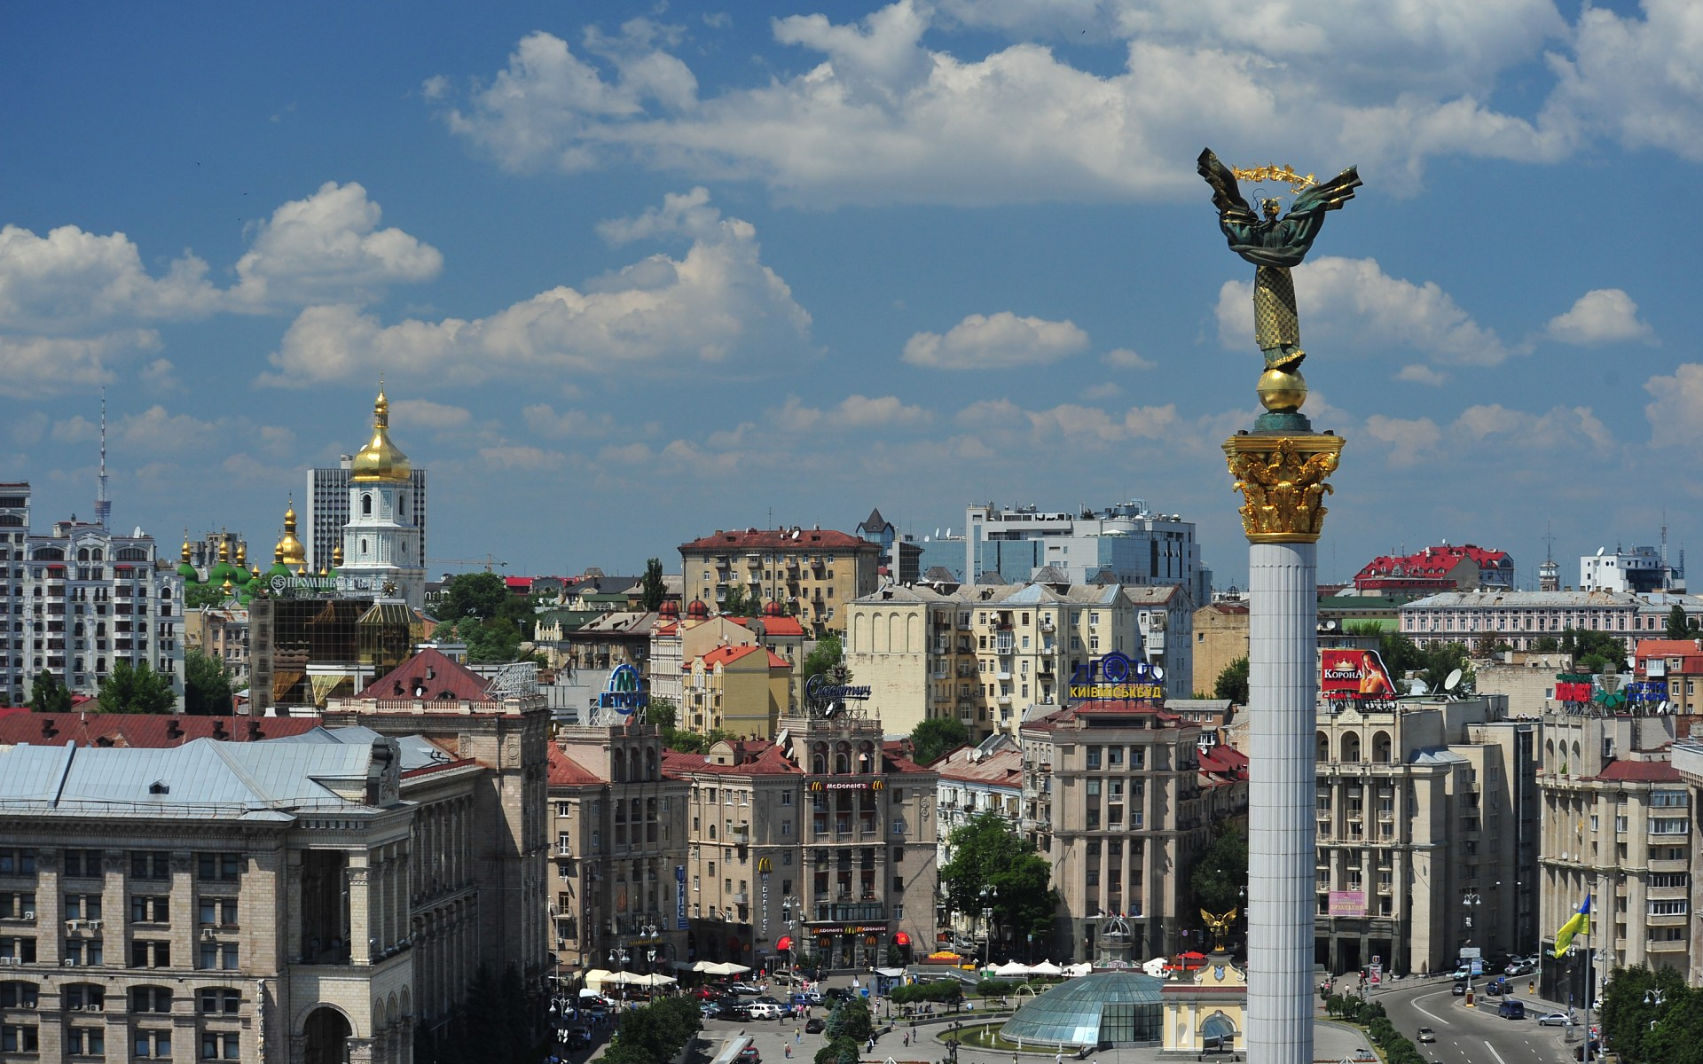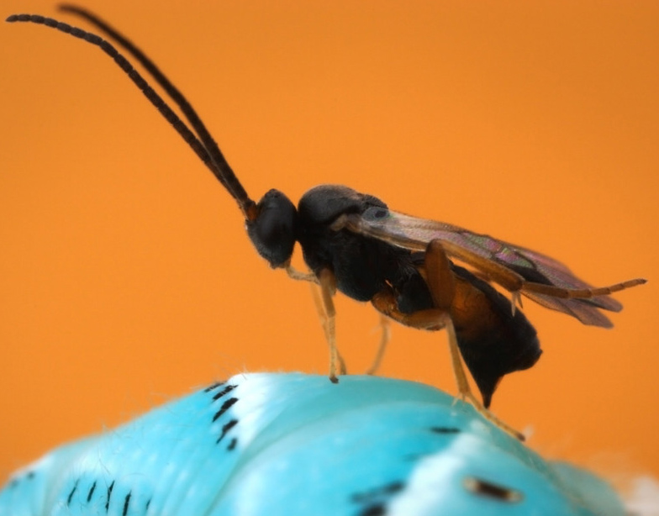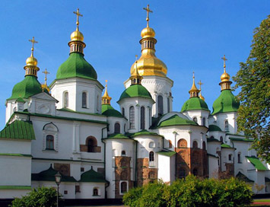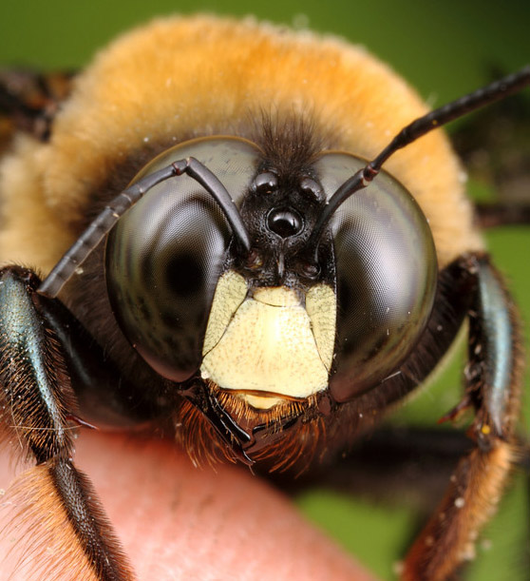
III Symposium of CIS on Hymenoptera
May 26th-30th, 2014, Kiev, UKRAINE.
FIRST ANNOUNCEMENT

Ukrainian Entomological Society in the cooperation with the I.I. Schmalhausen Institute of Zoology of National Academy of Sciences of Ukraine (Kiev) and Institute for Evolutionary Ecology of National Academy of Sciences of Ukraine (Kiev) (former name is the Scientific Centre for Megalopolis Ecomonitoring and Biodiversity Research of National Academy of Sciences of Ukraine) announce the preparation for III-rd Symposium of CIS countries (Commonwealth of Independent States) on hymenopterous insects (Hymenoptera) which will be held on May 26th–30th, 2014 in Kiev, Ukraine.
Plenary and Section reports (oral and posters) on all aspects of the study of the order Hymenoptera are planned at the Symposium.

The Organizing Committee

Chairman – Academician of National Academy of Sciences of Ukraine Vladimir Grigorievich RADCHENKO.
Deputy Chairmans – Professor Marina Dmitrievna ZEROVA; Correspondent-member of National Academy of Agricultural Sciences of Ukraine Leonid Ivanovich BODNARCHUK, Dr Alexei Vasilievich GUMOVSKY.
Secretary – Dr Victor Nikolaevich FURSOV.
Members – Prof. Alexander Pavlovich RASNITSYN, Dr Sergey Alexandrovich BELOKOBILSKY, Prof. Arkadiy Stepanovich LELEI; Dr. Dmitriy Rafaelievich KASPARYAN,
Dr Svetlana Vasilievna KONONOVA, Dr Anatoliy Grigoievich KOTENKO, Prof. Alexander Grigorievich RADCHENKO.

The following Sections are planned at the Symposium:
1. Morphology and Systematics.
2. Paleontology and Phylogeny.
3. Fauna and Zoogeography.
4. Biochemistry, Genetics and Cell Biology.
5. Ecology, Physiology and Behavior.
6. Hymenoptera Breeding and its Practical Value.
7. Social Insects.
The number, the name and the amount of Sections could be changed depending on the number and topics of reports. The Organizing Committee reserves the right to reject applications that do not meet the subjects/topics and requirements of the Symposium or having low scientific level.
Speaking time: Plenary reports – 30 min., Sectional reports – 15 min.

Working language – Russian. Oral and Poster Presentations in English are welcome.

Symposium will not be able to provide special English guides or complete synchronized English translation at all Sections of the Symposium (only some oral presentations would be translated by Organizing Committee’s participants if it would be requested).
Participants from other countries rather than Commonwealth of Independent States (other countries than Russian-speaking) are welcome as guests and participants.

Amount of Symposium’s organizational fee will be specified in the Second Circular.

It is planned to publish short materials (Abstracts of reports, submitted in Russian or English) before the Symposium.
It is planned to publish materials of oral reports presented at the Symposium (which must be submitted before Symposium in Russian, or English) in a separate book (collection of papers) after the Symposium.

For those wishing to study materials in the collections of the I.I.Schmalhausen Institute of Zoology of National Academy of Sciences of Ukraine (Kiev, Ukraine), it will be organized, as well as some tours to the city and its suburbs.
If you wish to participate in the Symposium, please send us the APPLICATION FORM
(by e-mail) prior to November 01, 2013 with the following information about you:

1. Last name, first name, middle name (in full).
2. Full job with the address.
3. Current position.
4. Academic degree, academic rank.
5. Preliminary title report (it is required for forming sections).
6. Address for communication (office and /or home), telephone number, and, please, obligatory – electronic mail (e-mail).
7. Participation form (Report, paper, Poster, author or co-author).
8. Order of hotel reservation.

Please, tell your colleagues about the Symposium, as well as direct your questions or suggestions to the Organizing Committee at the address:
I.I.Schmalhausen Institute of Zoology of the National Academy of Sciences of Ukraine, Bogdana Khmelnitskogo 15, Kiev-30, 01601, Ukraine. Tel. (+38) - (066) -071-9530; e-mail: (FURSOV Viktor
Nikolaevich): ufensia@gmail.com and by e-mail (RADCHENKO Vladimir Grigorievich): rvg@izan.kiev.ua

Information and news (Circulars) about the Symposium will be posted on the Internet at the addresses:
https://sites.google.com/site/entomologicnetovaristvo/home/ogolosenna-ta-novini
http://www.zin.ru/Animalia/Coleoptera/rus/hymen014.htm
http://mebrc.org

Organizing Committee of the III-rd Symposium of the CIS countries on Hymenoptera

