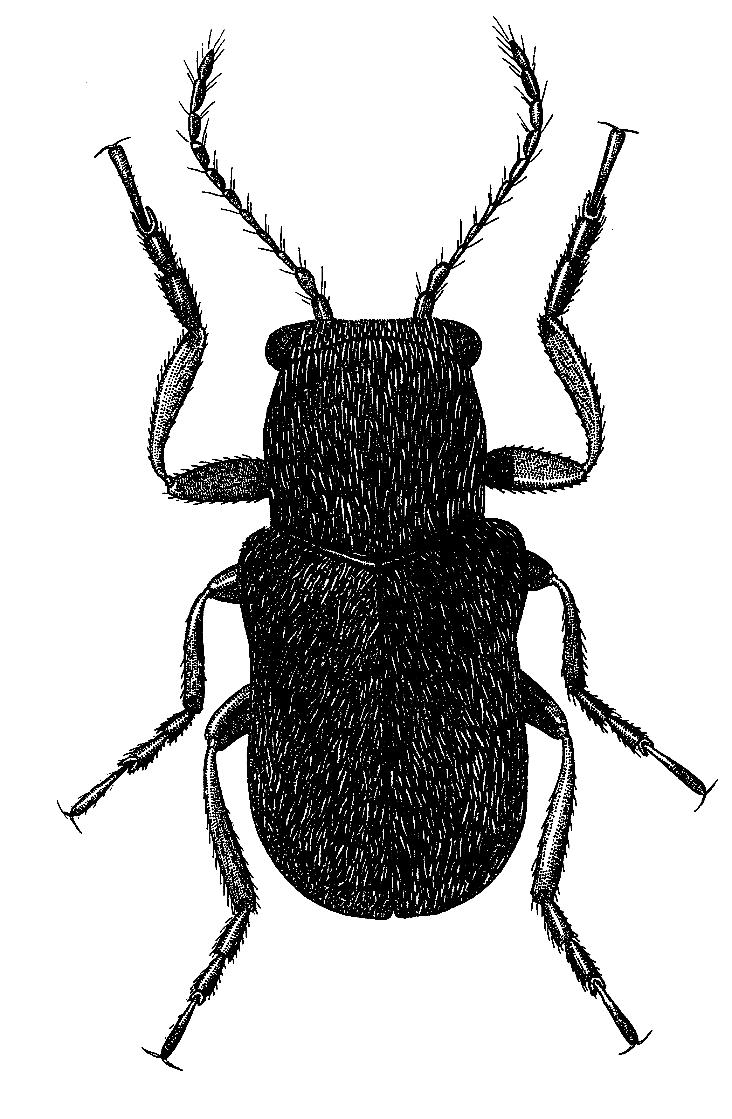
Рис. 53 - Stylosomus major Brt.

